Relational Algebra

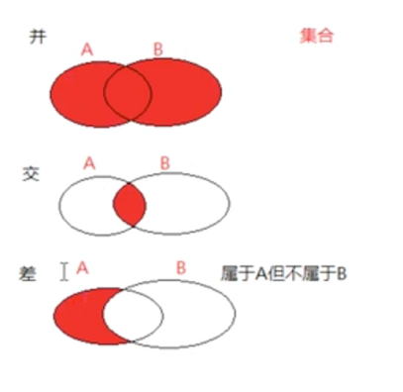

ch2関係代数 kankei daisuu かんけいだいすう

# Union, difference, Cartesian product

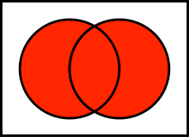

union, ∪, add, boolean or ||, venn diagram

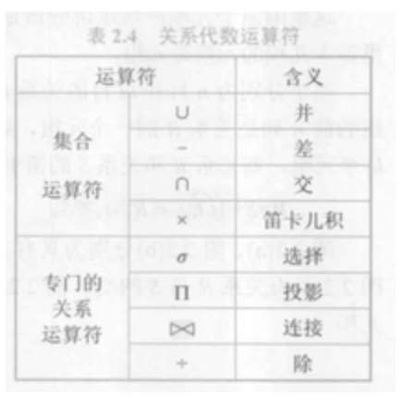

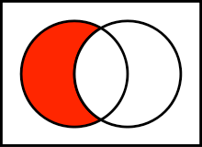

difference, - , /, subtract(minus),

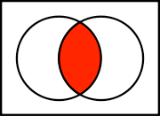

intersection, ∩, bool and &&

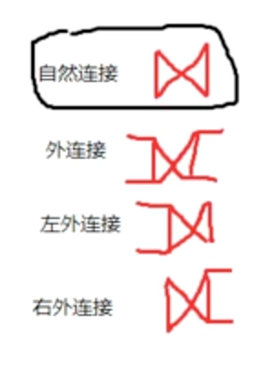

# Selection, projection

selection, sigma, σ, select rows(tuples)

σP(r)

select_row condition(predicate)(schema_r)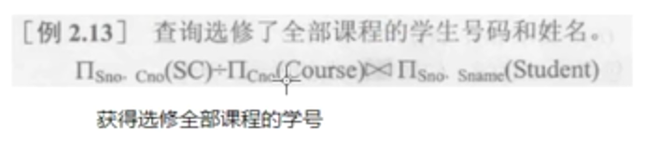

projection, upper pi, Π, attributes(columns)

ΠA(r)

select_col set_A (schema_r)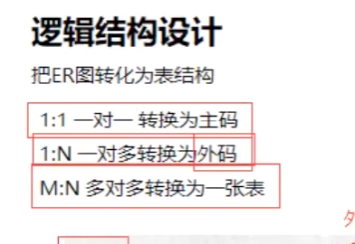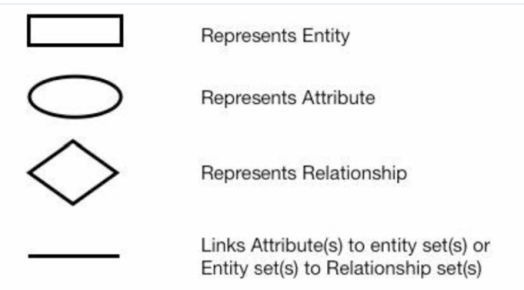

# Relational Model

1) Entity Relationship Diagram ERD

an entity drawn as a rectangle. entity = rectangle = table

relationship sets are represented by a diamond.

attributes are drawn as ovals.

>> attributes = column = field = degree(the number of columns)

-------------------------------------------------------------------------

>>row = tuple = cardinality(the number of rows)

2) schema an instance

relational schema:

AUTHOR(Author_ID: char, lastname: varchar, firstname: varchar, email: varchar, city: varchar, country: char)

relation instance: a table with data

video 1 cha2 relational algebra ​​并 差 交 笛卡尔积笛卡尔积 运动员握手​例题​

fin​​

relational algebra

https://en.wikipedia.org/wiki/Relational_algebra#Selection_(%CF%83)

wikipedia, set of methematics

https://en.wikipedia.org/wiki/Set_(mathematics)#Basic_operations

wikipedia, venn diagram

https://en.wikipedia.org/wiki/Venn_diagram

arizona didb week3

https://www.coursera.org/learn/data-in-database/lecture/qh5my/relational-algebra-query-language

Data in Database, Arizona State University

<https://www.coursera.org/learn/data-in-database>

relational algebra quiz

<http://cws.cengage.co.uk/rcc_databases/students/mcqs/Chapter4.htm>